Abies forrestii

Abutilon ‘Ashford Red’
Abutilon ‘Pink Parasol'

Abutilon Nabob (Dark red)

Acer

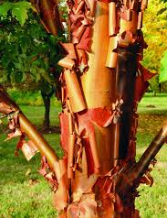
Acer griseum
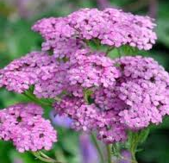
Achillea millefolium lilac
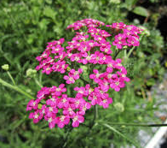
Achillea millefolium pink
Acis nicaeensis French Snowflake

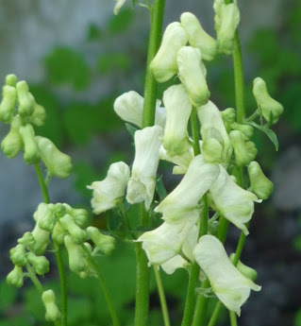
Aconitum ‘Ivorine’
Aconitum elwesii

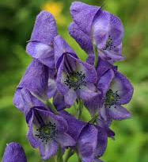
Aconitum sachalinense
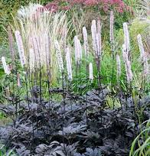
Actaea simplex
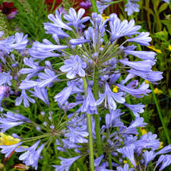
Agapanthus blue
Agapanthus Ex Keith Wiley
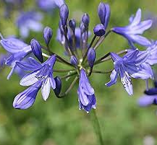
Agapanthus 'Morning Star'
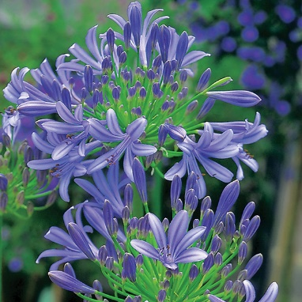
Agapanthus Headbourne hybrids
Agapanthus ‘Queen Mother’
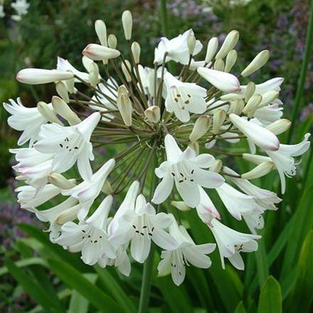Agapanthus white-flowered
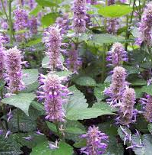
Agastache rugosa
‘Honey Bee Blue’
Albuca Shawii

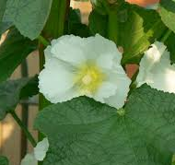
Alcea rosea white-flowered
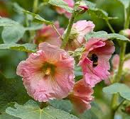
Alcea rosea apricot
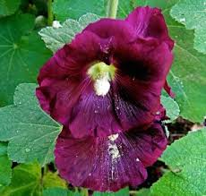
Alcea rosea burgundy
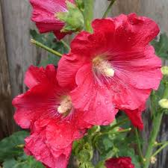
Alcea rosea coral
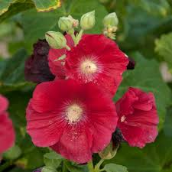
Alcea rosea red
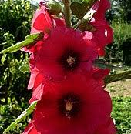
Alcea rosea deep red
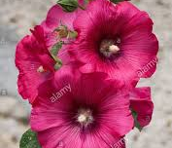
Alcea rosea dark pink
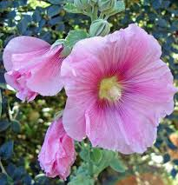
Alcea rosea pink
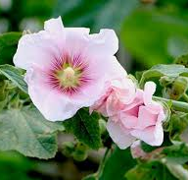
Alcea rosea small pink
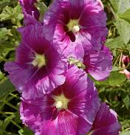
Alcea rosea magenta
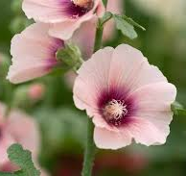
Alcea rosea cream with
dark centre

Alcea rosea pale pink

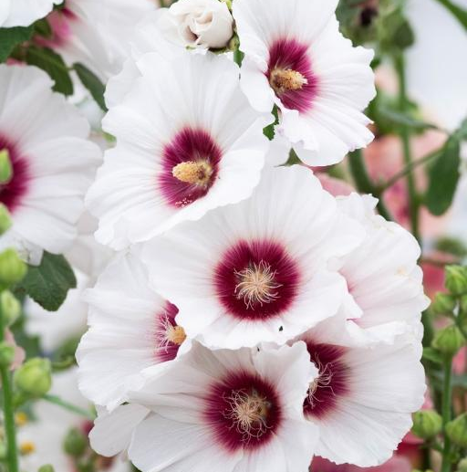
Alcea rosea white with
burgundy centre

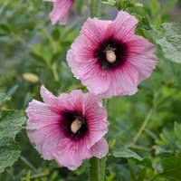
Alcea rosea pink with burgundy centre

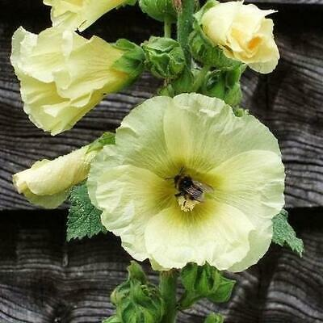
Alcea rosea lemon
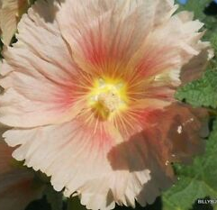
Alcea rosea yellow and orange
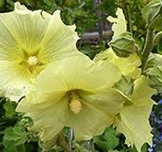
Alcea rosea yellow
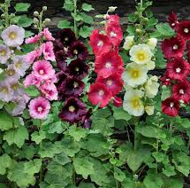
Alcea rosea mixed
Allium small flowers
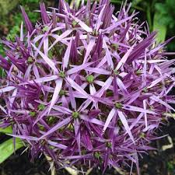
Allium cristophii
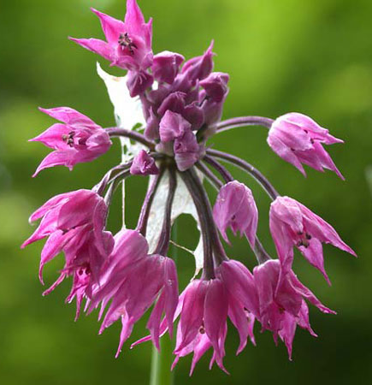
Allium cyathophorum var. farreri
Allium fistulosum Welsh Onion
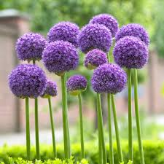
Allium 'Gladiator'
Allium ‘Gladiator’ giant
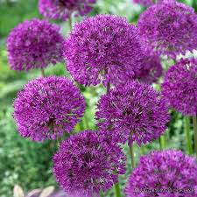
Allium hollandicum ‘Purple Sensation’
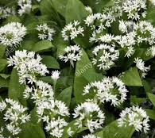
Allium oleraceum
Allium siculum Sicilian Honey Garlic
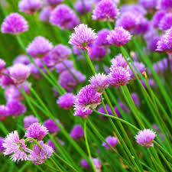
Allium schoenoprasum
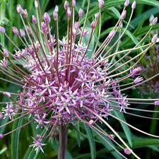
Allium schubertii
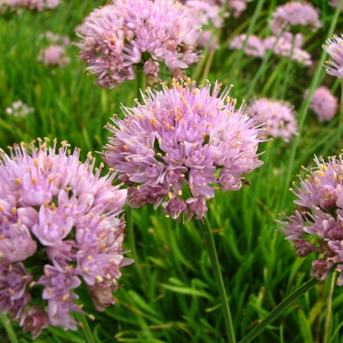
Allium senescens
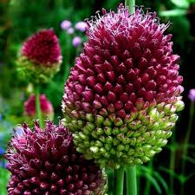
Allium sphaerocephalon
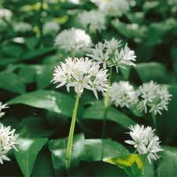
Allium tuberosum
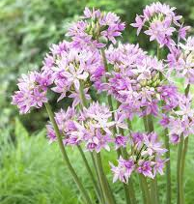
Allium unifolium
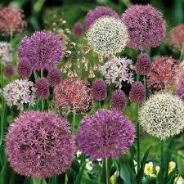
Allium mixed
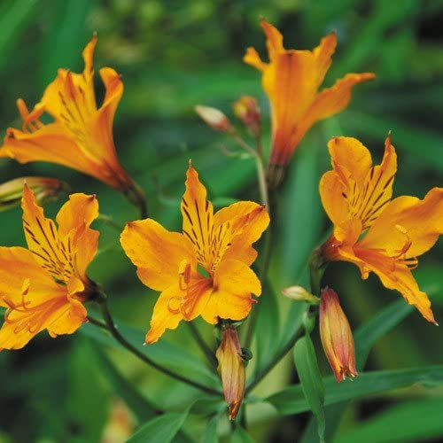
Alstroemeria aurantiaca
Alstroemeria aurea
Althaea armeniaca (mallow)
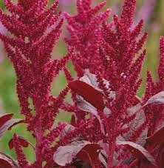
Amaranthus cruentus
Amaranthus ‘Pony Tails mixed’ (Love Lies Bleeding)
Amberboa ‘Desert Star’
Ammi majus ‘Graceland’
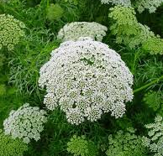
Ammi visnaga
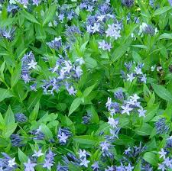
Amsonia ‘Blue Ice’
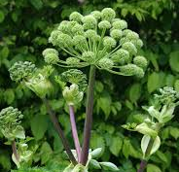
Angelica archangelica
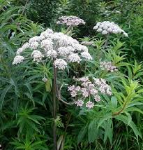
Angelica sylvestris

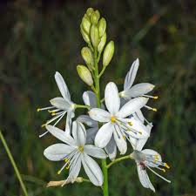
Anthericum ramosum

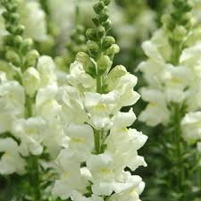
Antirrhinum white
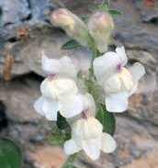
Antirrhinum sempervirens
Aquilegia Off white- slightly
pink-flowered
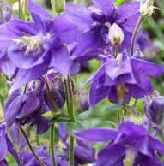
Aquilegia purple-flowered
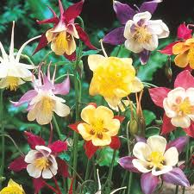
Aquilegia mixed
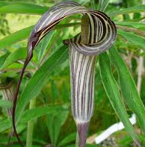
Arisaema consanguineum
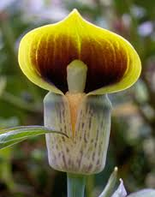
Arisaema flavum

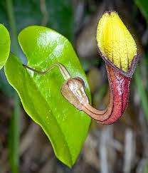
Aristolochia sempervirens
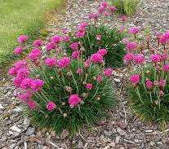
Armeria
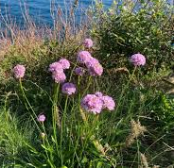
Armeria euscadiensis

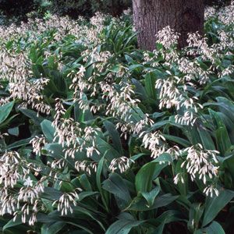
Arthropodium cirratum
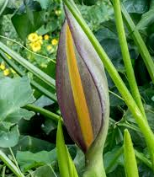
Arum concinnatum
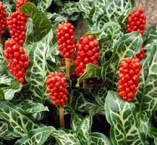
Arum italicum
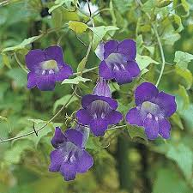
Asarina scandens
Asclepias tuberosa orange
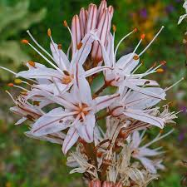
Asphodelus ramosus
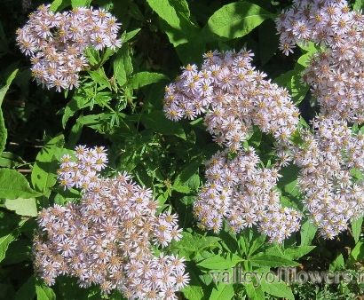
Aster albescens

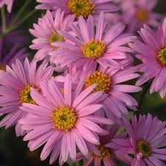
Aster 'Pink Zenith'
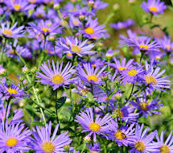
Aster purple-flowered
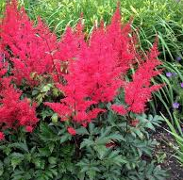
Astilbe red
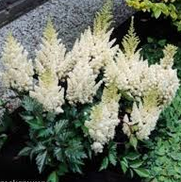
Astilbe white
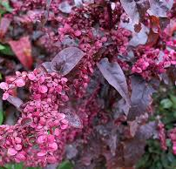
Atriplex hortensis (Red Orache)
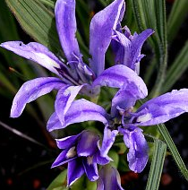
Babiana sp.
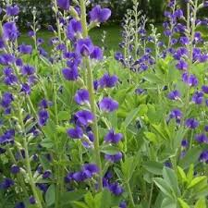
Baptisia australis
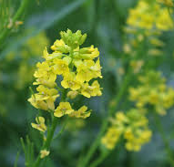
Barbarea vulgaris
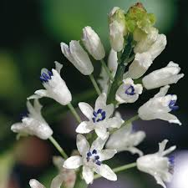
Bellevalia romana
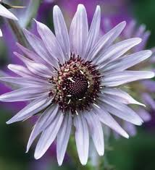
Berkheya purpurea
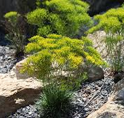
Bigelowia nuttallii

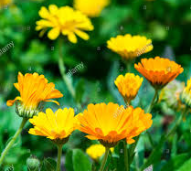
Calendula officinalis mixed
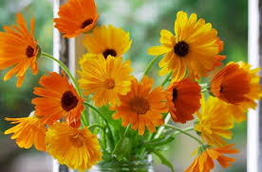
Calendula orange and yellow
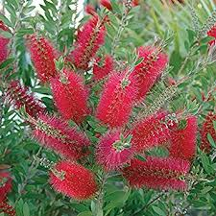
Callistemon (Red Bottlebrush)
Camassia leichtlinii ‘Alba’

Campanula alliariifolia (Cornish Bellflower)

Campanula lactiflora ‘Alba’
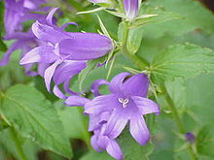Campanula latifolia
Campanula latifolia 'Roger Wood'
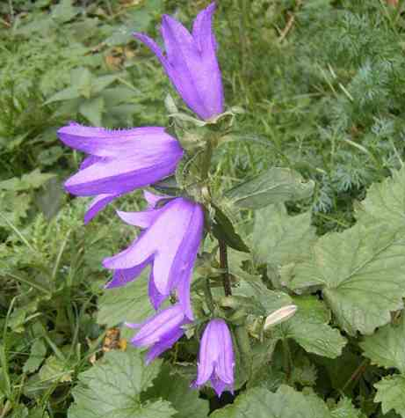Campanula trachelium
Canna ‘Madame Angèle Martin' pale salmon
Canna orange
Canna yellow
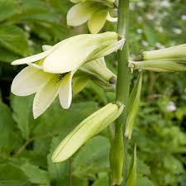
Cardiocrinum cordatum
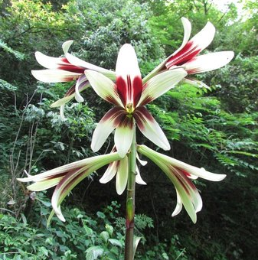Cardiocrinum giganteum
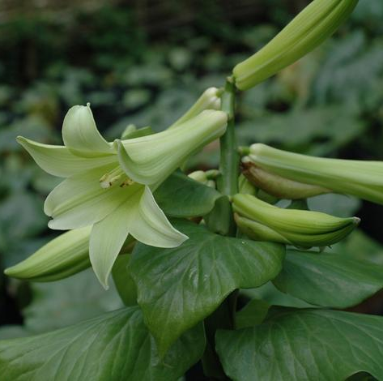
Cardiocrinum giganteum pale green
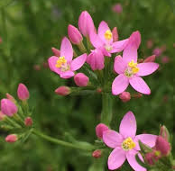
Centaurium erythraea
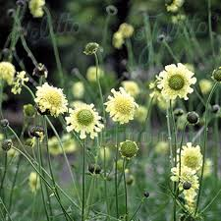
Cephalaria gigantea
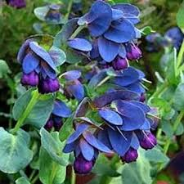
Cerinthe major ‘Purpurescens’

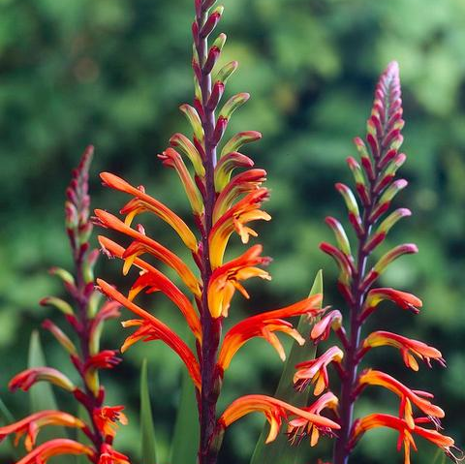
Chasmanthe floribunda
'African Flag'
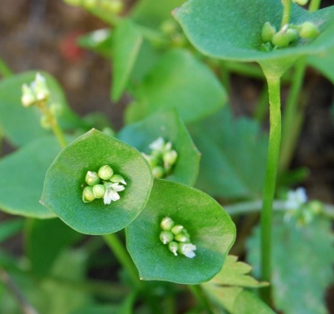
Claytonia perfoliata (syn. Montia perfoliata)
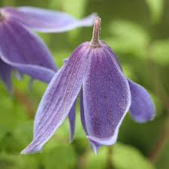
Clematis alpina
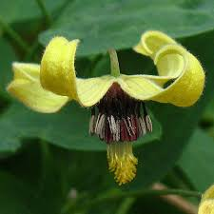
Clematis intrica 'Harry Smith'
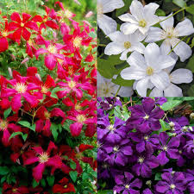
Clematis viticella
Cleome hassleriana 'Helen Campbell' scented white flowers
Clivia miniata ‘Chubb’s Peach’
Clivia miniata ‘Field Marshall’
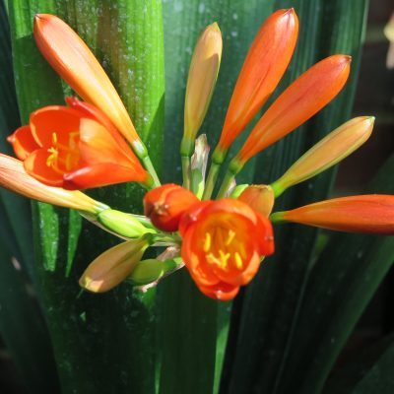
Clivia miniata orange
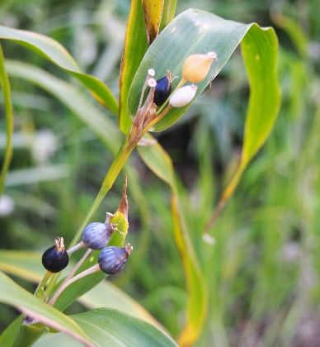
Coix lacryma-jobi

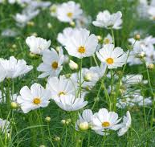
Cosmos bipinnatus white
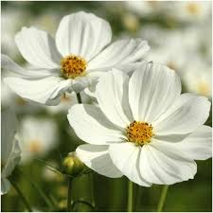
Cosmos bipinnatus ‘Purity’

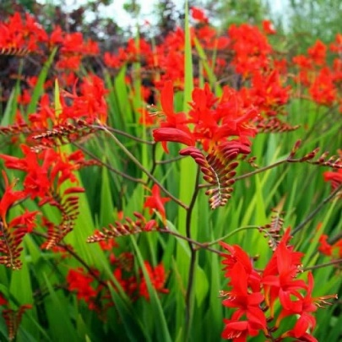
Crocosmia ‘Lucifer’
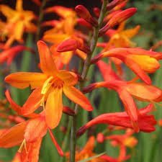
Crocosmia red orange flower
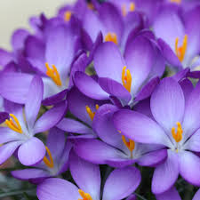
Crocus tommasinianus
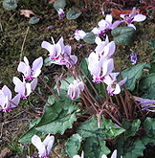
Cyclamen hederifolium
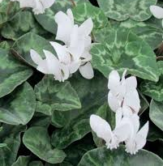
Cyclamen hederifolium 'Album'
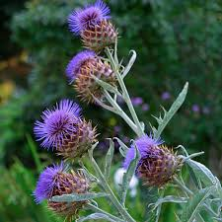
Cynara cardunculus

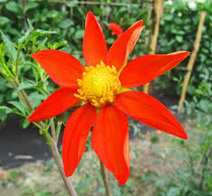
Dahlia coccinea var. palmeri
Dahlia merckii Pink single flowers

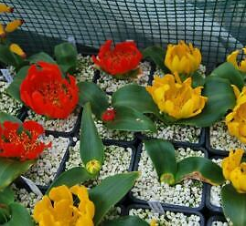
Dalbenya aurea - Hyacinth family (rare)
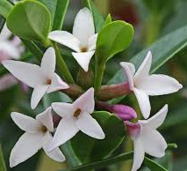
Daphne tangutica

Datura stramonium (Thorn Apple)

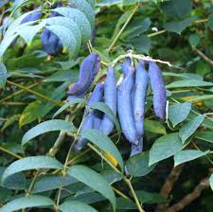
Decaisnea fargesii

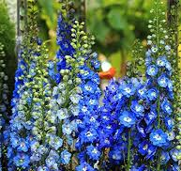
Delphinium blues
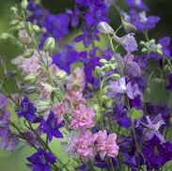
Delphinium dark blue
Delphinium pink
Delphinium purple
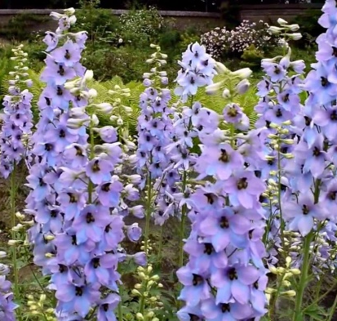
Delphinium requienii
Delphinium requienii mauve grey
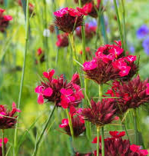
Delphinium sky blue
Dianthus barbatus (Sweet William)
Dianthus carthusianorum
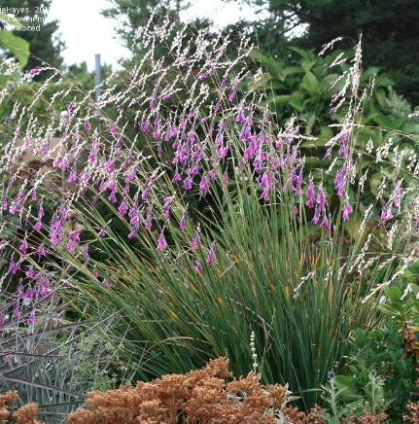
Dierama (mixed)
Dierama pink and coral
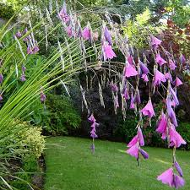
Dierama pulcherrimum
Digitalis ferruginea (Rusty Foxglove)
Digitalis ferruginea ‘Gigantea’ (apricot-brown foxglove)
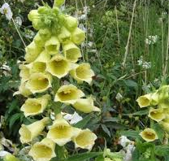
Digitalis grandiflora
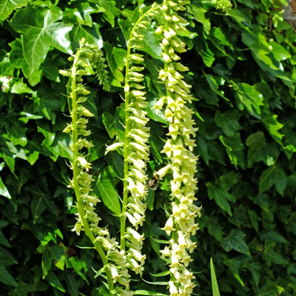Digitalis lutea
Digitalis (mixed)
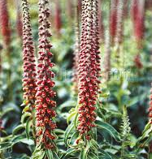
Digitalis parviflora
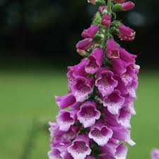
Digitalis purpurea
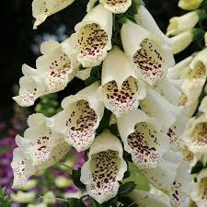
Digitalis purpurea cream-flowered
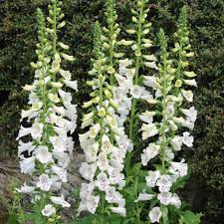
Digitalis purpurea white-flowered
Dregea sinensis
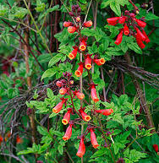
Eccremocarpus scaber
Echinacea ‘Hot Papaya’
Echinacea pallida pale purple
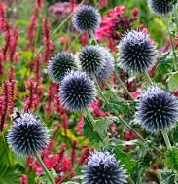
Echinops (Globe Thistle)
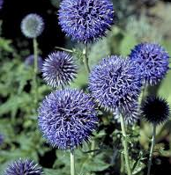
Echinops ritro

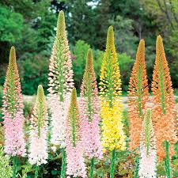
Eremerus hybrids
Erigeron ‘Sea Breeze’
Erodium manescavii (Heron’s Bill)
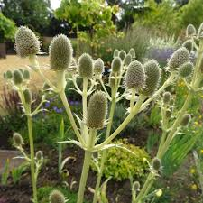
Eryngium agavifolium
Eryngium ‘Big Blue’
Eryngium ‘Blue Waves’
Eryngium bourgatti blues
Eryngium varifolium
Eucomis bicolor
Euonymus europaea (European spindle)
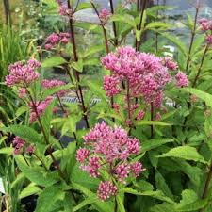
Eupatorium purpureum
Euphorbia lathyris
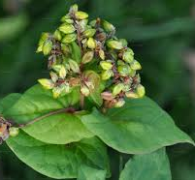
Fagopyrum tataricum (Buckwheat)
Fatsia
Ferrula communis (giant fennel)
Filipendula rubra Venusta' (Queen of the Prairie)

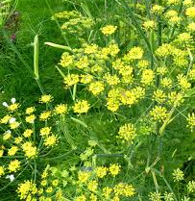
Foeniculum vulgare (Fennel)

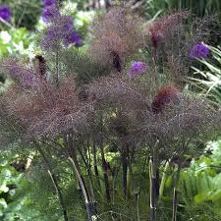
Foeniculum vulgare ‘Purpureum’
Francoa ramosa (Bridal Wreath0
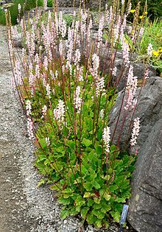
Francoa sonchifolia
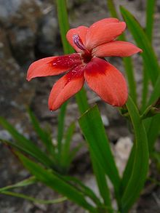
Freesia laxa
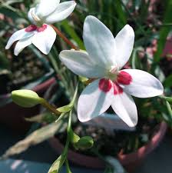
Freesia laxa ‘Joan Evans’
Freesia laxa orange
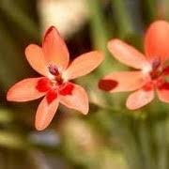
Freesia laxa Orange with red spot
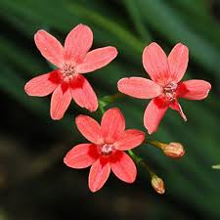
Freesia laxa red-flowered
Freesia laxa (syn. Anomatheca)
blue
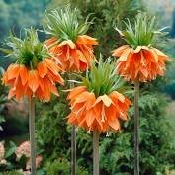
Fritillaria imperialis
Fritillaria imperialis ‘Aurora’
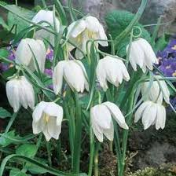
Fritillaria meleagris 'Alba'
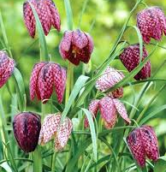
Fritillaria meleagris
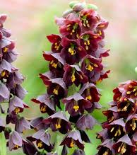
Fritillaria persica
Galtonia
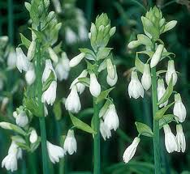
Galtonia candicans
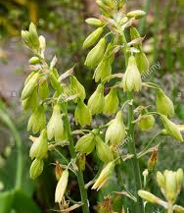
Galtonia princeps
Galtonia regalis (Golden Berg Lily) greenish/yellow
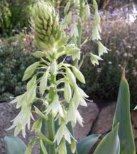
Galtonia viridiflora dwarf form
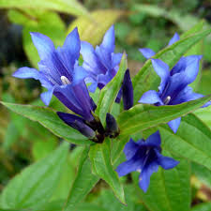
Gentiana asclepiadea
Geranium maculatum
Geranium nodosum ‘Blueberry Ice’
Geranium nodosum ‘Hexham Big Eye’
Geranium pratense
Geranium psilostemon

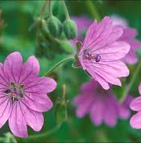
Geranium pyrenaicum
Geranium pyrenaicum f. albiflorum

Geranium schlechteri
Geum single orange
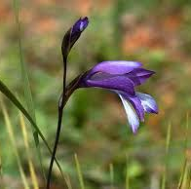
Gladiolus atroviolaceus
Gladiolus dalenii (Dragon’s Head Lily)

Gladiolus murielae (Abyssinian gladiolus)
Gladiolus purple
Habranthus brachyandrus (Rain Lily)

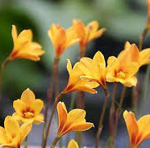
Habranthus tubispathus
Hedychium coronarium (Ginger Lily) white

Helianthus annuus ‘Autumn Time’
Helianthus salicifolius yellow

Hemerocallis lilioasphodelus (Day Lily) yellow

Hieracium lanatum (Hawkweed)

Hieracium scullyi (Scully’s Hawkweed)

Heterotifica villosa

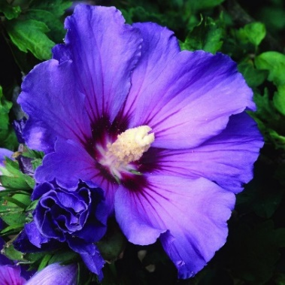
Hibiscus Blue-flowered
Hosta ‘Fire and Ice’
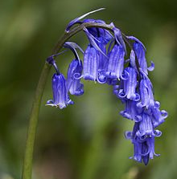
Hyacinthoides non-scriptus
Hypericum orientale
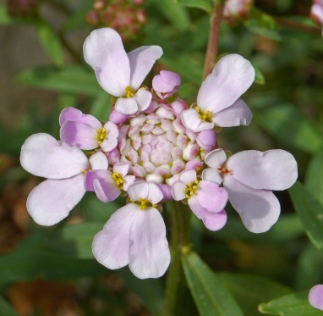
Iberis umbellata (Candytuft)
Iberis umbellata ‘Betty Swainson’
Impatiens sultanii (Busy Lizzie)
Incarvillea forrestii

Indigofera tinctoria

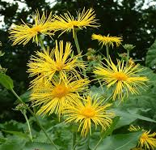
Inula magnifica
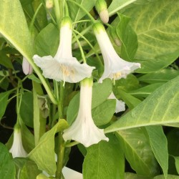
Iochroma australe ‘Andean Snow’
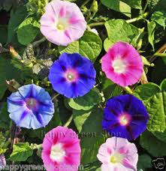
Ipomoea
Ipomea purpurea

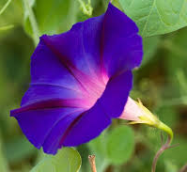
Ipomoea ‘Star of Yalta’

Iris californicae (Pacific Coast Iris)

Iris domestica (Leopard or Blackberry Lily)
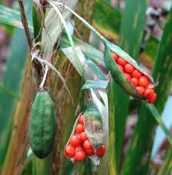
Iris foetidissima
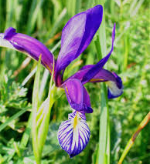
Iris graminea
Iris orientalis white flowers, yellow streaks
Iris planifolia (syn. Juno planifolia)
(Juno Iris)
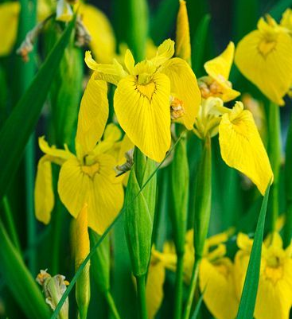
Iris pseudacorus ‘Elegans’
Iris siberica ‘Hoar Edge’
Iris siberica ‘Mrs Rowe’
Iris siberica ‘Regality’
Isatis tinctoria (Woad)
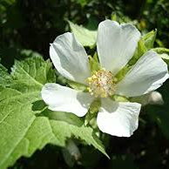 Kitaibelia vitifolia

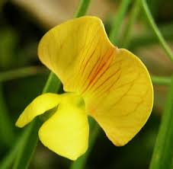
Lathyrus annuus
Lathyrus chloranthus green
Lathyrus hirsutus ‘Little Gems’
Lathyrus laevigatus (Smooth Pea)

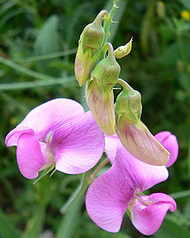
Lathyrus latifolius (Perennial Sweet Pea)
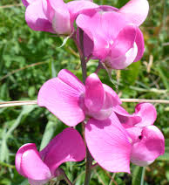
Lathyrus latifolius Pink-flowered
Lathyrus latifolius deep mauve-pink
Lathyrus odoratus ‘Bouquet Mixture’
Lathyrus odoratus ‘Bouquet Navy’
Lathyrus odoratus ‘Bouquet Pink’
Lathyrus odoratus flamed mixture
Lathyrus odoratus ‘Jack Ellis’ maroon-purple
Lathyrus odoratus ‘Mammoth Salmon Pink’
Lathyrus odoratus ‘Melanie Ann’ salmon pink on cream
Lathyrus odoratus ‘My Navy’ navy blue
Lathyrus odoratus ‘Princess’ pale pink
Lathyrus odoratus ‘Solway Shimmer’ lavender flush
Lathyrus odoratus ‘Spencer Mix’
Lathyrus odoratus ‘Summer Romance’ pastel shades
Lathyrus odoratus ‘Sunshine Lavender’
Lathyrus odoratus ‘Giant White’
Lathyrus sativus ‘Albus’ white

Lathyrus transylvanicus pale orange

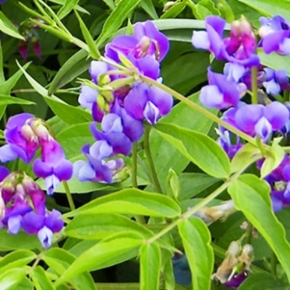
Lathyrus vernus

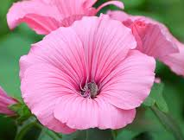
Lavatera
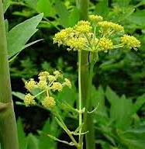Levisticum officinale (Lovage)
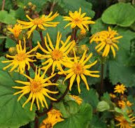
Ligularia dentata
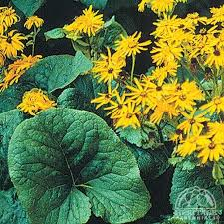
Ligularia dentata ‘Desdemona’
Lilium auratum (Golden Ray Lily)
Lilium bulbiferum var. croceum orange

Lilium candidum 'cascade strain'

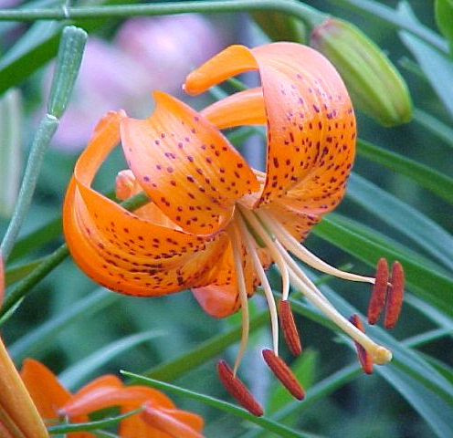
Lilium davidii
Lilium hansonii (Turk’s Cap Lily)

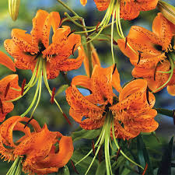
Lilium henryi
Lilium ‘Imperial Silver’

Lilium maroccana (Licilia Peach, Toadflax)

Lilium martagon
Lilium martagon ‘Claude Shride’

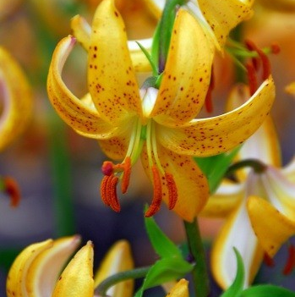
Lilium martagon ‘Mrs Backhouse’
Lilium martagon Pink-flowered
Lilium martagon ‘Russian Morning’
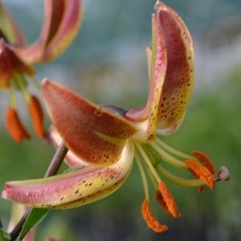
Lilium martagon 'Slate's Select'

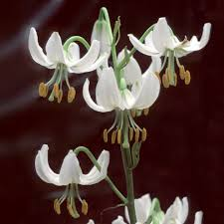
Lilium martagon var. album

Lilium pardalinum (Leopard Lily)

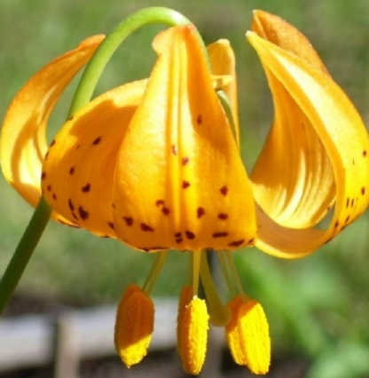
Lilium pardalinum subsp. wigginsii
Lilium pumilum
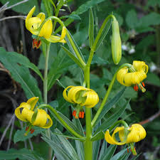
Lilium pyrenaicum
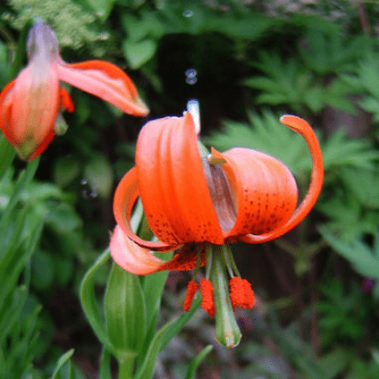
Lilium pyrenaicum f. rubrum
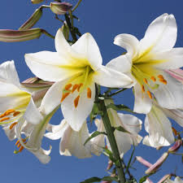
Lilium regale 'Album'

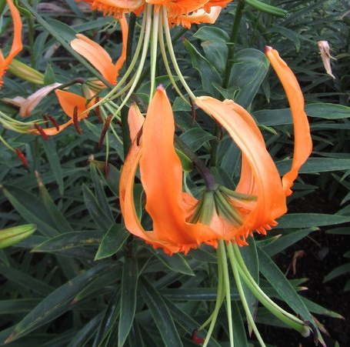
Lilium rosthornii
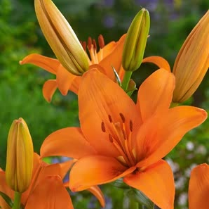
Lilium rosthornii vivid orange
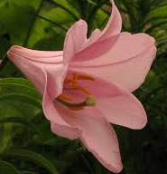
Lilium rubellum (rare)
Lilium ‘White Planet’ (Trumpet Lily)
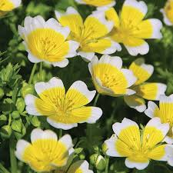
Limnanthes douglasii (Poached Egg Plant)
Limonium latifolium (Sea Lavender)
Linaria purpurea
Lobelia cardinalis ‘Queen Victoria’
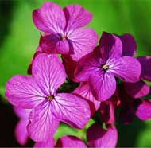
Lunaria annua
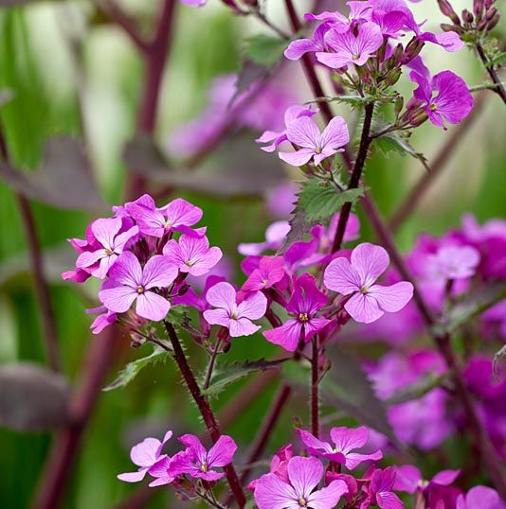
Lunaria annua ‘Chedglow’
Lupinus albus white
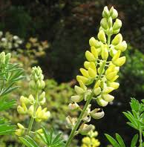
Lupinus arboreus
Lupinus polyphyllus large-leaved

Lupinus ‘Masterpiece’

Lupinus mixed

Lupinus pink

Lupinus red and yellow
Lupinus white
Lupinus yellow
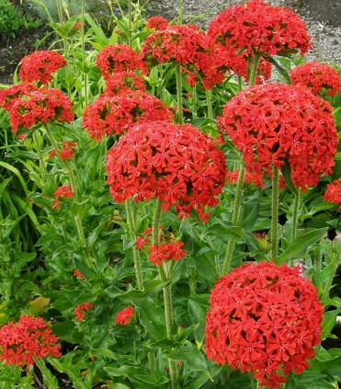
Lychnis chalcedonica
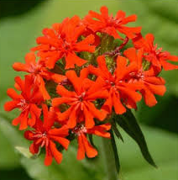
Lychnis chalcedonica (Maltese Cross)
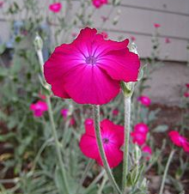
Lychnis coronaria
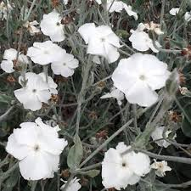
Lychnis coronaria ‘Alba’
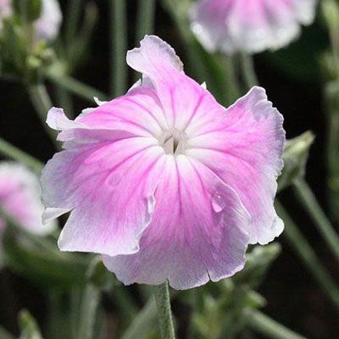
Lychnis coronaria ‘Angel's Blush’
Lychnis coronaria ‘Blood Red’

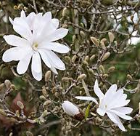
Magnolia stellata

Malva variegated
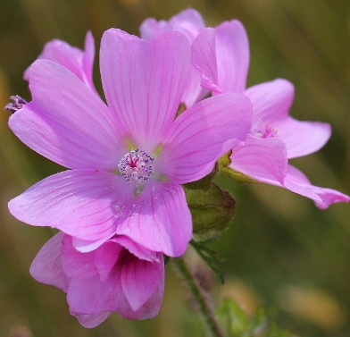
Malva moschata

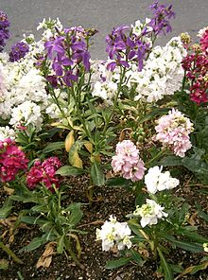
Matthiola incana
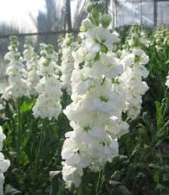
Matthiola incana ‘Alba’
Lophospermum scandens syn.
Maurandya lophospermum

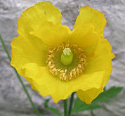Meconopsis cambrica

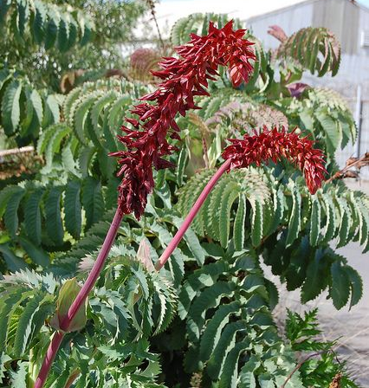
Melianthus major (Giant Honey Flower)
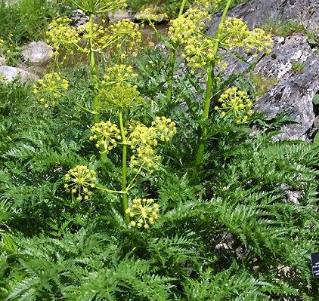
Molopospermum peloponnesiacum
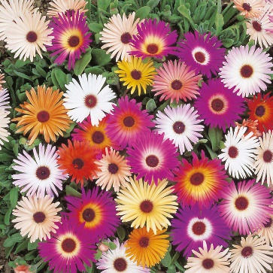
Mesembryanthemum
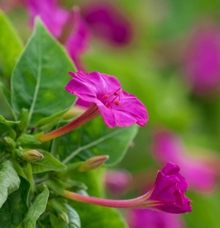
Mirabilis jalapa (Marvel of Peru or 4 O'clock flower)

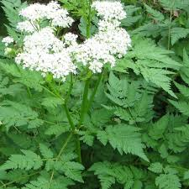
Myrrhis odorata (Sweet Cicely)
Narcissus bulbocodium (Petticoat Daffodil)

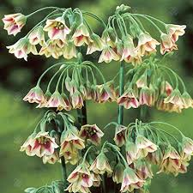
Nectaroscordum siculum
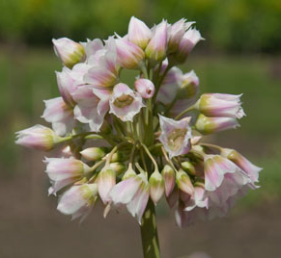
Nectaroscordum siculum subsp. bulgaricum

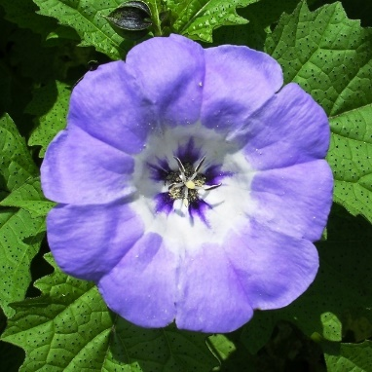
Nicandra physalodes
Nicotiana affinis

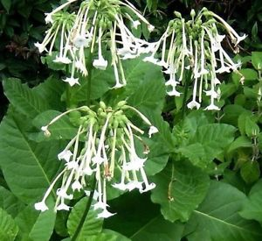Nicotiana sylvestris
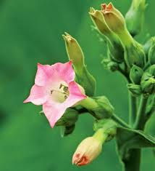
Nicotiana tabacum

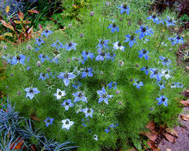
Nigella damascena
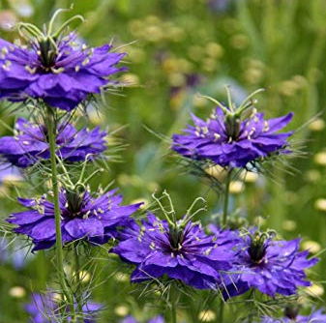
Nigella damascena ‘Oxford Blue’
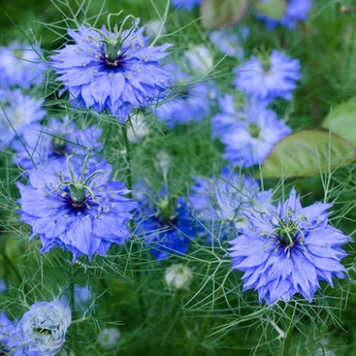
Nigella sativa
Oenothera biennis apricot (Evening Primrose)

Oenothera biennis yellow (Evening Primrose)

Omphalodes linifolia (Venus’s Navelwort) white flowers
Origanum vulgare ‘Pink Mist’
Ornithogalum narbonense (Star of Bethlehem)

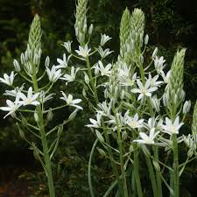
Ornithogalum pyramidale
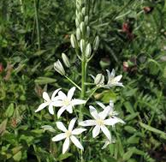
Ornithogalum pyrenaicum
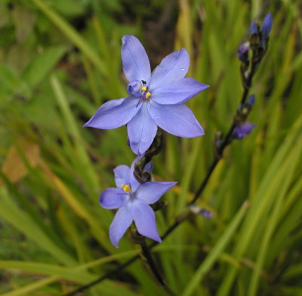
Orthrosanthus laxus
Osteospermum purple
Paeonia
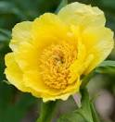
Paeonia delavayi f. lutea
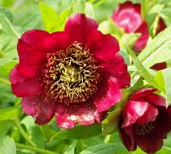
Paeonia delavayi

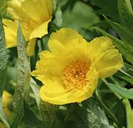
Paeonia ludlowii

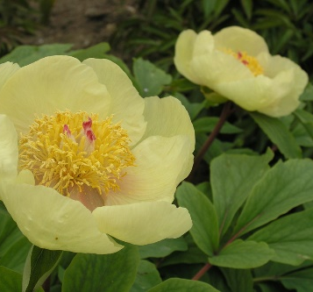
Paeonia mlokosewitschii
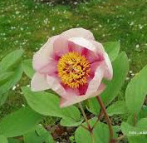
Paeonia mlokosewitchii (yellow white/red)

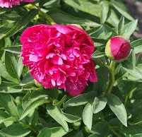
Paeonia officinalis
Paeonia rockii
Paeonia suffruticosa (Tree Peony)

Paliurus spina-christi (Christ’s Thorn)

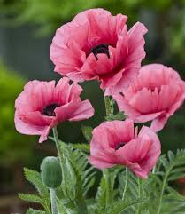Papaver orientale Pink-flowered

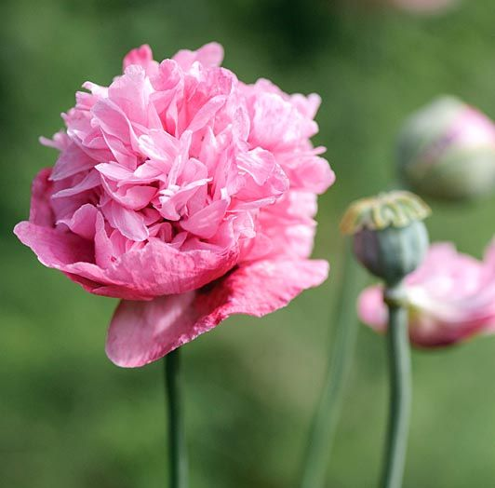
Papaver somniferum Double pink

Papaver somniferum double red

Papaver somniferum mixed
Papaver somniferum pale pink

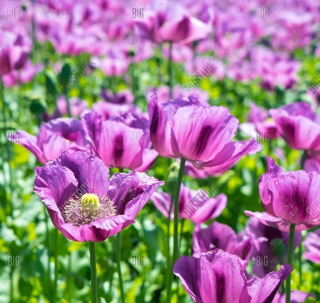
Papaver somniferum purple

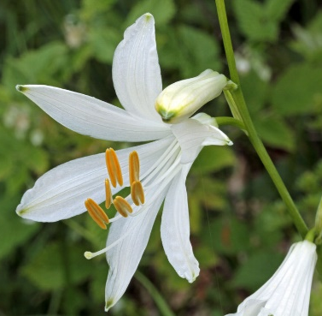
Paradisea liliastrum (Paradise Lily)

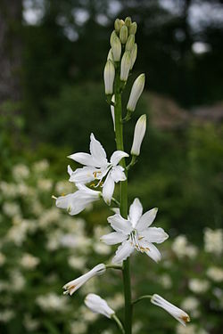
Paradisea lusitanica (Paradise Lily)

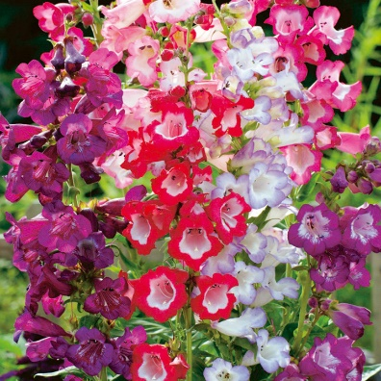
Penstemon
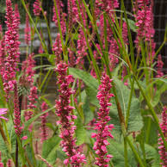
Persicaria amplexicaulis ‘Firetail’
Petunia exserta
Petunia purple

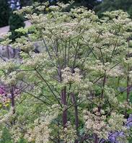
Peucedanum veticillare
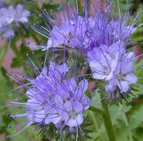
Phacelia tanacetifolia
Phlomis russeliana (Turkish Sage)

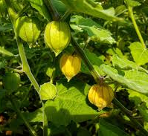
Physalis peruviana
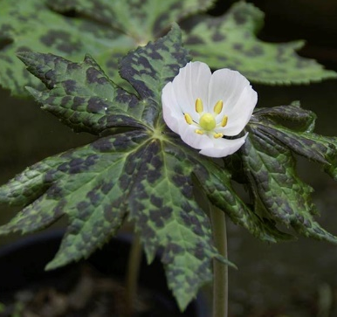
Podophylum hexandrum
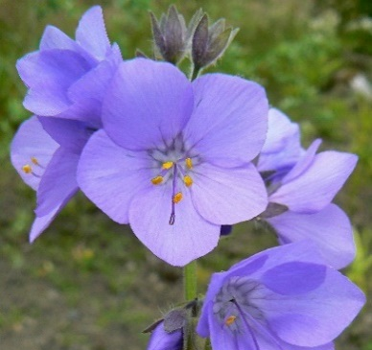
Polemonium caeruleum subsp. himalayanum
Polemonium himalayca
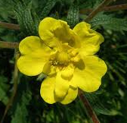
Potentilla pedate
Potentilla recta
Potentilla rupestris (Rock Cinquefoil)

Primula (Bog Primula)
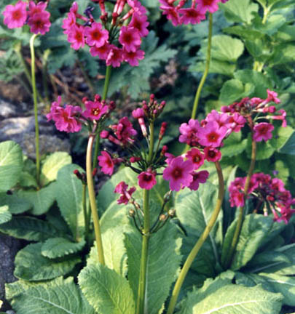
Primula burmanica
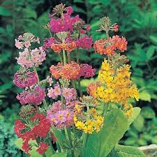
Primula japonica

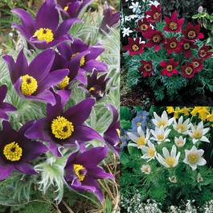
Pulsatilla
Pulsatilla vulgaris blue

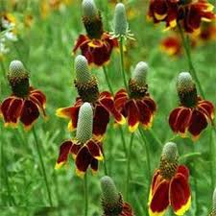
Ratibida columnifera

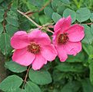
Rosa moyesii

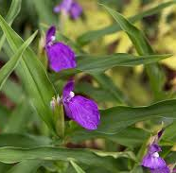
Roscoea humeana

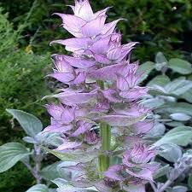
Salvia turkestanica
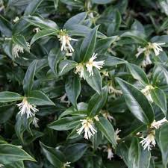
Sarcococca confusa
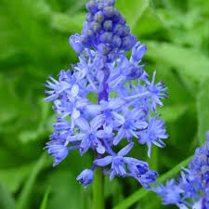
Scilla litardierei
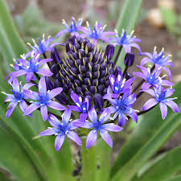
Scilla peruviana
Setaria macrostachya ‘Will Scarlet’
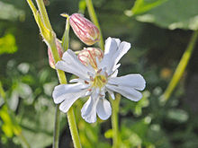
Silene caucasica
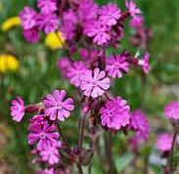
Silene dioica
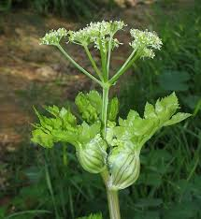
Smyrnium olusatrum
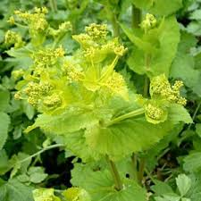
Smyrnium perfoliatum
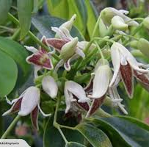
Stauntonia hexaphylla evergreen climber

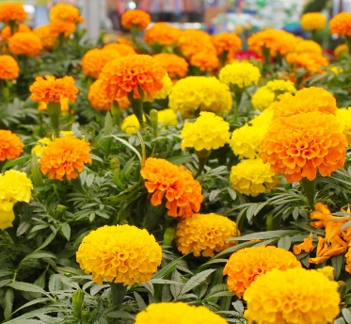
Tagetes erecta
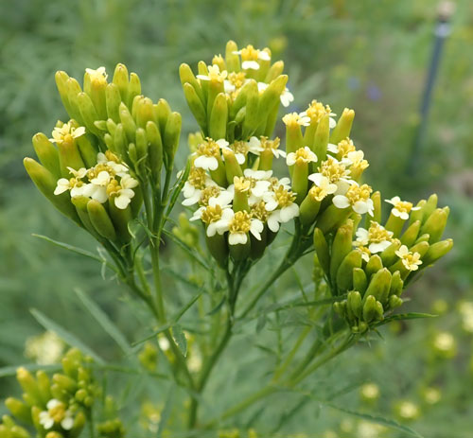
Tagetes minuta
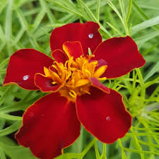
Tagetes patula ‘Cinnabar’ (French Marigold)

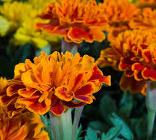
Tagetes patula (French Marigold)
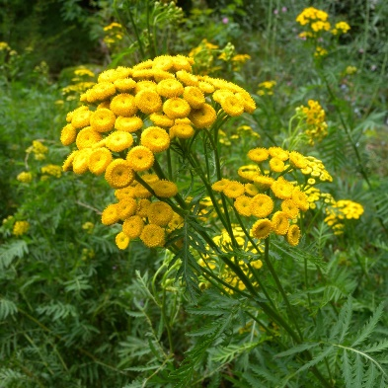
Tanacetum vulgare
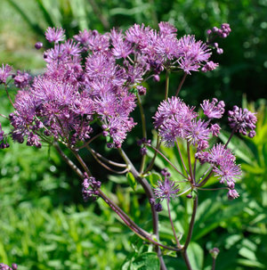
Thalictrum aquilegiifolium

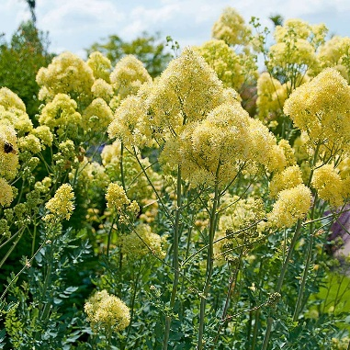
Thalictrum flavum subsp. glaucum
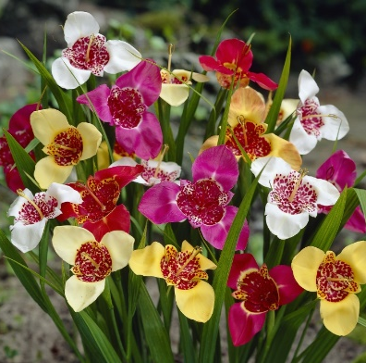
Tigridia pavonia
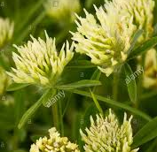
Trifolium ochroleucon (Sulphur Clover)
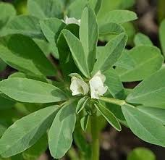
Trigonella foenum-graecum
(Fenugreek)

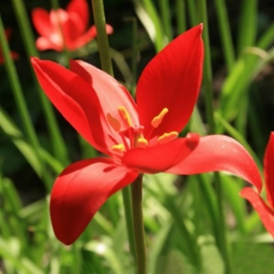
Tulipa sprengeri
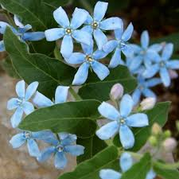
Tweedia
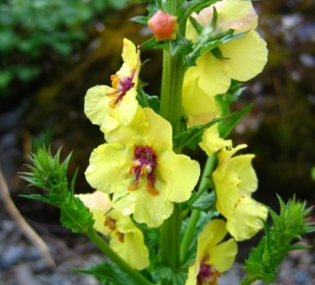Verbascum blattaria
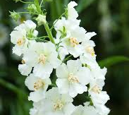
Verbascum phoeniceum ‘Flush of White’
Verbascum bombyciferum

Verbascum olympicum

Verbascum phoeniceum

Verbascum Thapsus

Verbascum x hybridum

Verbena bonariensis

Verbena officinalis

Veronica

Veronicastrum virginicum

Vicia cracca

Vicia orobus

Viola cornuta

Vitex agnus-castus

Xanthoceras sorbifolium

Vitex agnus-castus

Xanthoceras sorbifolium

Zephyranthes andersonii

