Scientific application guidance 2023
Table of Contents
Initial checks 1
A Scientific Collection 2
Awards and medals 2
Collection 2
Education 2
Herbarium specimens, photographs, genebanking. 3
Labelling and interpretation 3
Legal 3
Outreach & contacts 3
Nomenclature & taxonomy 3
Publications 4
Records 4
Research 4
Case studies 5
Dr John Vanderplank – Passiflora species 6

To save repetitive typing throughout the document a Scientific Collection Holder will be abbreviated to SCH, and the word applicant will be used for the person or institution applying for Scientific Status whether they currently have a National Plant Collection or not.

Initial checks
- Complete a coordinator review to make sure that they are meeting the requirements of a National Plant Collection (NPC); if they aren’t this is a good time to initiate a discussion about how they could achieve this and offer some assistance.
- If you and the applicant are comfortable that they are meeting the requirements for NPC status and would like to apply for, or prepare to apply for Scientific status then discuss the requirements with them and how much work may need to be done to achieve them.
- Not all applicants will meet the requirements immediately, but suggestions can be made to work towards it.
- The first step towards application is to complete the Scientific Application form and submit for preliminary comment. This will enable a mentor to be assigned by the PCC; this doesn’t necessarily mean that the applicant is ready for their final submission for Scientific status.

A Scientific Collection
A National Plant Collection with Scientific Status is a collection that is actively used to further new knowledge of a plant group. The holder is known as an authority in the field, has published research and has in general ‘gone the extra mile’ for their genus or group.
For a Scientific application it is important that the applicant is able to provide evidence, as part of the application, that they are fulfilling what is required. This is why the emphasis throughout these notes is on demonstrating what they have done, or currently do. Not all of the areas may apply to all applicants, for example some may have no awards or medals; but thought needs to be carefully given to establishing achievements and reflecting these fully in the application form and the material supporting it.
Awards and medals
Many current SCHs have received awards for their work from specialist plant societies, the Royal Horticultural Society or other bodies. They may have used the collection as part of a thesis for graduate or post-graduate study.
They will quite often have received medals for successful entries at the larger flower shows, or smaller specialist events. However not all plants can be exhibited, and not all Collection Holders would be inclined to do this.
Collection
The applicant needs to prove that the Collection demonstrates the peak of cultivation practice for the plants concerned. The Collection should be in good health, tidy, clean and well-organised. It ought to be easy to locate plants from the accession list and vice versa. Pests, diseases and disorders that the genus is prone to are well controlled and the Collection Holder has in-depth knowledge of these. They should also have a good picture of potential pests/diseases that may reach the UK/EU in the future.
The acquisition/accession policy of the collection (what is added to the collection, how and why?) needs to be well-developed, and integrated with ongoing research work. This should be appended to the application form if available.
Conservation
The applicant needs to be involved in conservation work and hold a good understanding of the conservation status of their plants. For plants of wild origin this would mean the IUCN Red List status, and for cultivars the Threatened Plants Project.
Education
Many SCHs make it a part of their work to educate others, whether by giving talks and lectures, creating interpretation for their gardens or plants, creating an environment in which the display is itself educational (a bed showing taxonomical relationships, a glasshouse showing the interactions between plants and pollinators).
The applicant needs to demonstrate that they are keen to pass on their knowledge of the genus to others, and that they have put into action ways of doing this. What is the evidence of this?

Herbarium specimens, photographs, gene banking
The collection ought to have been recorded and preserved in as many ways as possible. Different methods suit different genera but it would be expected for an applicant for Scientific status to have completed or be in the process of completing a full set of herbarium specimens (with duplicates deposited at a herbarium such as RHS Wisley; to have completed or be in the process of completing a full set of photographs of individual plants in the collection of sufficient standard to be used for the purposes of identification; to have explored the subject of seed or gene banking with the aim of making the genetic material in the living collection available for posterity.
The applicant needs to demonstrate that they have made efforts to preserve and share the physical and genetic information held within the collection, to help future growers with identification and preserve genetic material.
Labelling and interpretation
The labelling must be clear and informative to visitors. If it is not possible to do this for reasons of security then interpretation must be available for visitors to enable them to easily identify plants in the collection. It should meet and exceed the standards set for National Plant Collections. (including Reference collections)
Interpretation for visitors is dependent on the type of visitor and the collection, but should be appropriate and informative to both. In small private collections or those held in private areas of public gardens, interpretation may not be necessary as the visitor would be personally shown around by the Collection Holder; in this situation a précis of the information given to visitors would be useful.
The applicant needs to demonstrate that they are keen to communicate as much information as possible to visitors, and have thought carefully about how to achieve this.
Legal
The applicant must be familiar with and adhere to all national and international legal frameworks within which they operate. This may include the Convention on International Trade in Endangered Species, the Convention on Biological Diversity, Plant Health legislation, Plant Breeder’s Rights and intellectual property rights, the Wildlife & Countryside Act. They will hold copies of all relevant permits and agreements for reference if requested.
Outreach & contacts
The applicant needs to demonstrate that they are active in the field of their genus, involved in the relevant specialist plant groups, discussion groups and fora that relate to it. They should be in regular contact with those doing research on the genus, both professional and amateur, and be keen to share information. Awareness of other important collections held both in the UK and internationally and how they relate to each other (in terms of duplication, complementary, overlapping coverage of the genus/group) is vital.
Nomenclature & taxonomy
The Collection Holder should be an authority on the nomenclature and taxonomy of their plants. They should have access to the latest monographs and use the most up-to-date accepted names. It may be that they are in disagreement with the latest revision, in which case a note should be made of why, and which one they prefer, with relevant authority.

Evidence of cooperation and communication with others working on their genus, to correct nomenclature and check and compare the identity of plants would be expected. The plants in the collection would be expected to have been verified ideally in conjunction with another authority on the group.
Records
The records kept for the collection should cover from its inception. There should be a record of decisions taken regarding the collection, all developments and set-backs (looking back over Annual Reports may help with this), publicity, events and exhibits and important visits. The plant records will differ according to genus, but need to include full name of plant, source, date of acquisition (where known) and accession number. It would be expected that further fields might include: death, reason for death, changes in nomenclature, name received as, propagation success & failure, location, collection number, field notes, breeder, parentage, provenance, description and so-on. Best practices in record keeping should be followed, with the records being kept consistently, accurately and ideally stored on a database.
Research
One of the most important roles of the SCH is that they need to have undertaken research into the collection, and that this research must have been published. This should be creative work undertaken to increase the sum total of knowledge about the genus or group of plants concerned. It should be used to establish or confirm facts, reaffirm the results of previous work, or solve new or existing problems. A research project may also be an expansion on past work in the field. The research may be collaborative or solo.
The applicant should be able to demonstrate a coherent direction to their research, if they are in the early stages of planning, it may be helpful to go through the process of a research proposal to clarify where they are going and why.
It would also be useful to read some of the publications of other SCHs and talk to them about their research, talk to others in the field of the genus concerned, and institutions that are currently working on research. The humorous flow chart on the next page might help too!
Publications
The Collection Holder needs to have carried out research on the collection, and this needs to have been published. It is difficult to specify suitable places for publication as these will depend on the type of research and the plants concerned. A suggestion would be to study the lists of publications given below for existing SCHs.
How to list your publications for the application form:
List of Publications:

• Order from earliest to current.
• Indicate authors according to original order as appears in the scientific paper plus indicate first and last page of article.
• Indicate complete name of article, paper and year of publication plus exact reference.
• Divide into sub-sections between the following: Refereed articles, Invited reviews, Book Chapters, Invited editorials, Commentaries, Edited and original books, others.
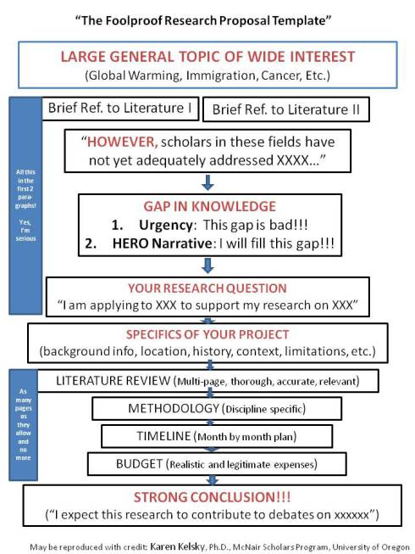

Case Study
Dr John Vanderplank – Passiflora species
Passiflora – R J R Vanderplank – Full Status 27/11/1985 – Scientific Status 26/2/1999
John Vanderplank’s Passiflora collection first received National Collection status in 1985, during the early years he expanded the collection and started researching various aspects of the plants. By the 1990s he had embarked upon a research degree with the Open University (‘The Sociology, taxonomy and ecology of the passifloras and factors influencing the long-term storage and germination of their seed’). This would be remarkable enough, were it not for the fact that his previous academic qualifications were two O’levels. As a result of much hard work he is now Dr John Vanderplank.
Work that John has done on his collection during the time he has had it includes fieldwork, identifying, studying and discovering species in their natural environment; collaborating with others nationally and internationally; creating a permanent exhibition of species demonstrating the uses to which they are put; researching their relationship with Heliconid butterflies and building an environment in which the two can interact; scanning electron microscope studies of pollen and seeds; enthusing and educating everyone he meets.
List of publications:
Vanderplank, J. (1987) New Passion flower hybrids. Royal Hort. Soc. J. 122(8): 367-370
Vanderplank, J. (1991) Passion Flowers & Passion Fruit Cambridge: MIT Press
Vanderplank, J. (1994) A growing passion Royal Hort. Soc. J. 119 (1): 28-33
Vanderplank, J (1996a) Passion Flowers 2nd ed. Cassells, UK
Vanderplank, J (1996b) Passiflora quadrifaria (Passifloraceae)
- SEM studies of pollen and seed – 2004.
- Projects
- Collaborations
  - Working with University of Mississippi, supplying plant material for research into flavonoids in Passiflora .
  - Providing material for University of Reading looking into evolutionary relationships between Passiflora species by means of genetic sequencing of chloroplast and mitochondrial DNA. and scadistic analysis.

