Plant Heritage Threatened Plant of the Year 2022
to be showcased at RHS Hampton Court Palace Garden Festival

At Plant Heritage we are keen to showcase rare and unusual plants, and we have the perfect opportunity for you to display your own threatened plant in our ‘Threatened Plant of the Year’ competition.

The winner in 2021 was Camellia ‘Yesterday’ – found growing in the garden of a Plant Heritage member. The public vote was won by Aspidistra ‘Irish Mist’ See all the shortlisted plants in 2021.
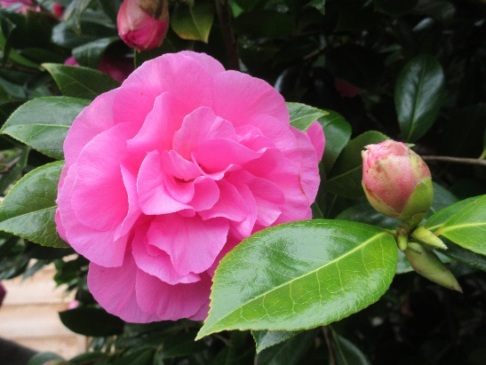
Could you receive the 2022 Threatened Plant of the Year trophy? The criteria are:

- It should be a named cultivar (such as Aspidistra 'Irish Mist' or Begonia 'Patricia Furness)
- The cultivar should have existed for at least 10 years: either grown in a garden, or available from nurseries before 2012
- It should not be regularly available for sale
2021 WINNER: Camellia × williamsii ‘Yesterday’ © Dr K Westbrook
© Malcolm Ovens

Applications, including a photo of the plant, can be submitted to Plant Heritage by an online form which will be available on our website from 14th February. We would love to hear about the history of your plant too, which could include information about the breeder, its association with people or places, or what makes this plant special to you.

The process:

- applications to be submitted by 16th May 2022

- all applications will be checked for eligibility against our Threatened Plants Programme data

- applicants will be notified by Friday 1st June as to whether they have been shortlisted and that their entry will be invited for display at Hampton Court

- the RHS Hampton Court Garden Festival runs from 4-9th July. Either the plant, or a good quality photo of the plant can be displayed

- the winner will be judged by a panel of horticulture experts and a public vote will run for the duration of the show

We look forward to receiving your applications and to hearing about your threatened plants. If you have any queries please get in touch through collections@plantheritage.org.uk.

